Source Citations and List of . . . Reports
KIPCUG Genealogy SIG June 21, 1999

Important!
The exact format of the citation is not important initially. Creating the citation is important.

Sources
The source is the reference that you are using as your documentation for the information being entered.

Citation Detail
The citation detail is the specific location within the source for the information being entered.

Citations
The citation is the combination of the source and the citation detail that documents the information entered for a tag.

Sure Codes (TMG)
- 3 - Primary Documentation
- 2 - Secondary Documentation
- 1 - Guess
- 0 - No Information
- - - Disproved Information

Example 1 – Obituary
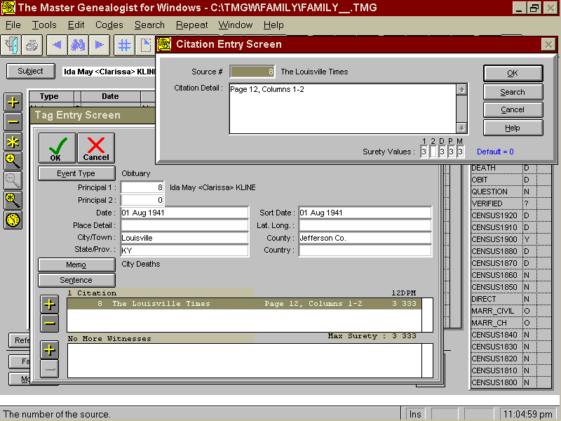

Example 2 - Census

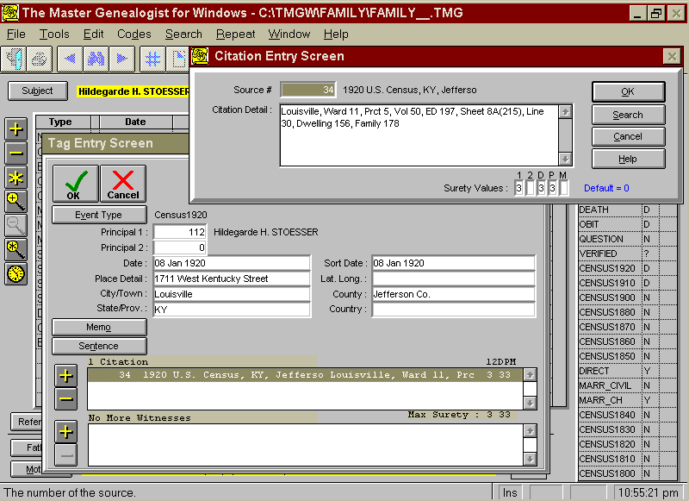

Example 3 - Marriage

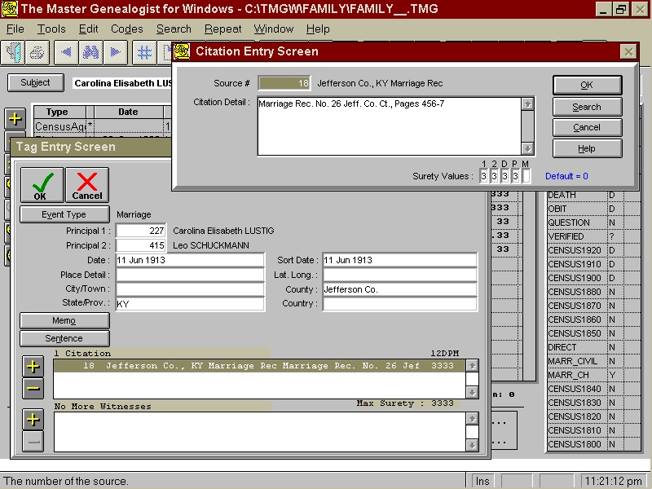

Example 4 - Death

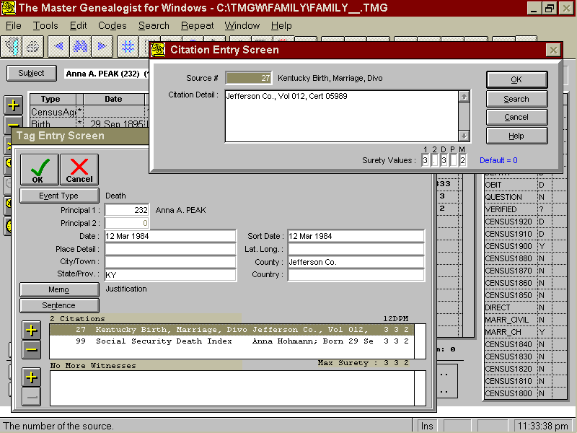

Example 5 - Deductive Reasoning

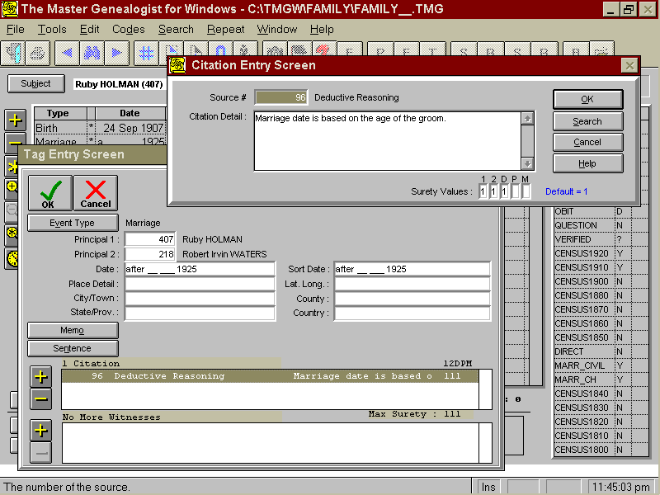

Master Source List

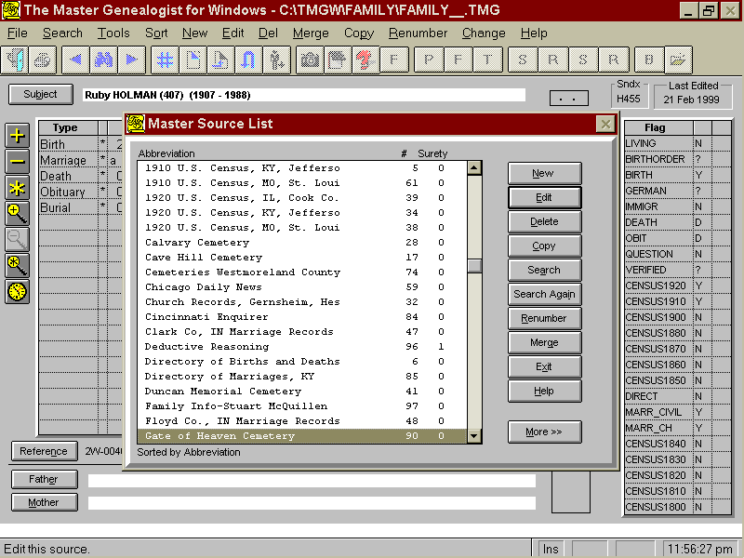

Conclusion
- Citations should be used as quickly as you are willing to enter the documentation.
- Information is only as good as your documentation verifying your sources.

List of . . . Reports Have It Your Way
Important!
Test the various report options to determine: 1) the report capabilities and 2) any necessary changes to your data input style.

List of . . . Reports
This category of reports is used to produce lists of citations, events, names, people, places, repositories, sources, tag types, tasks or witnesses.

Uses of List of . . . Reports
- Identifying your common input errors.
- Listing of all citations to verify that you have consistently entered your documentation.
- Listing of people that are missing documentation for an event.

Record Selection
The records for the report are selected using Boolean Logic, which is a search strategy for information retrieval.

Boolean Examples
- A = Death, B = >1910, C = Blank Date
- * A and B or C, (A and B) or C
- Deaths in or after 1910 and Blank Dates for All Events
- A and (B or C)
- Deaths in or after 1910 with Blank Dates

Other Features
- Can use part of a selection
- Starts with
- Contains
- Can use on/off features
- Is empty
- Is not empty
- Exists
- Does not exist

Conclusion
- List of Reports can be used to include only those records that you want in the report.
- Construct your selection criteria carefully.

