Citing Your Sources – Source Citations in TMG
KIPCUG Genealogy SIG April 19, 1999

Important!
The exact format of the citation is not important initially. Creating the citation is important.

Sources
The source is the reference that you are using as your documentation for the information being entered.

Citation Detail
The citation detail is the specific location within the source for the information being entered.

Citations
The citation is the combination of the source and the citation detail that documents the information entered for a tag.

Sure Codes (TMG)
- 3 - Primary Documentation
- 2 - Secondary Documentation
- 1 - Guess
- 0 - No Information
- - - Disproved Information

Example 1 - Obituary
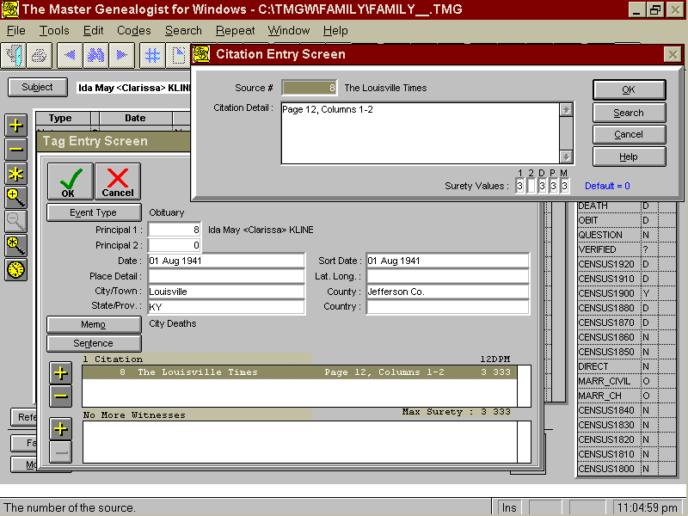

Example 2 - Census

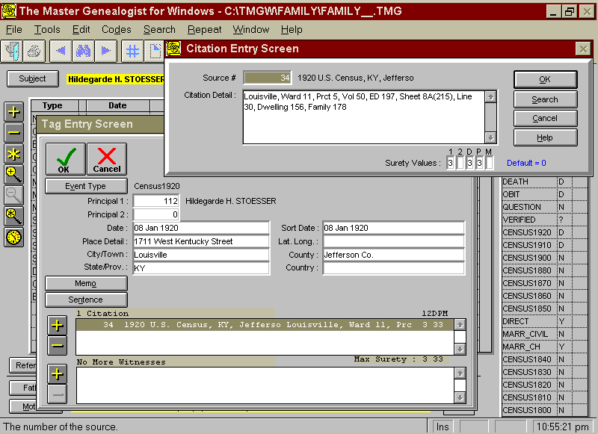

Example 3 - Marriage

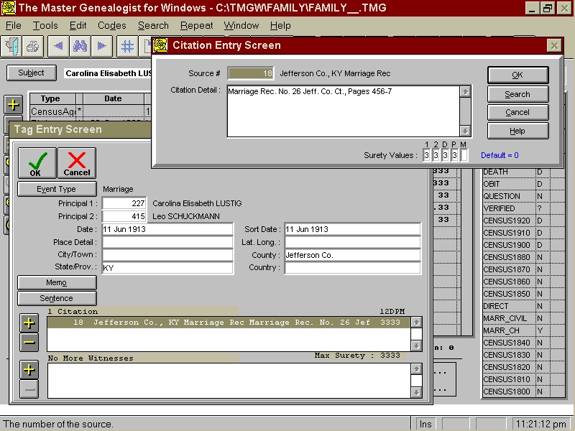

Example 4 - Death

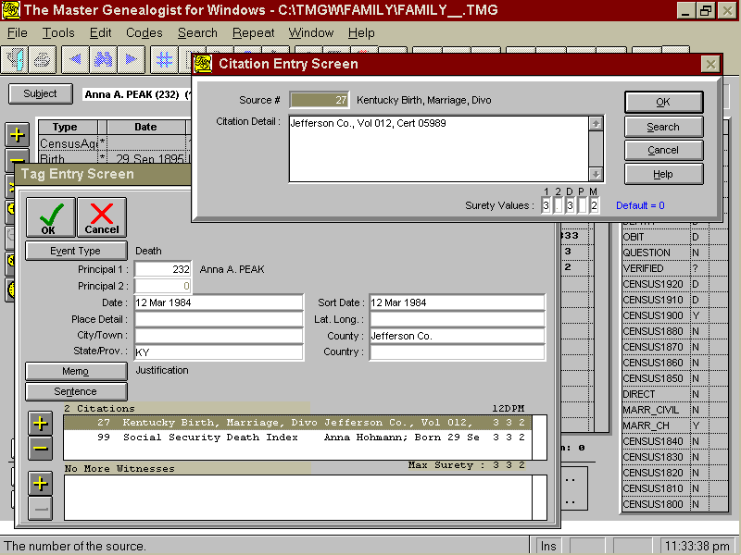

Example 5 - Deductive Reasoning

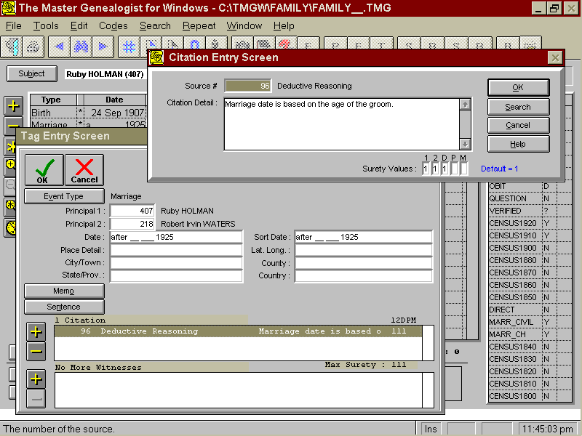

Master Source List

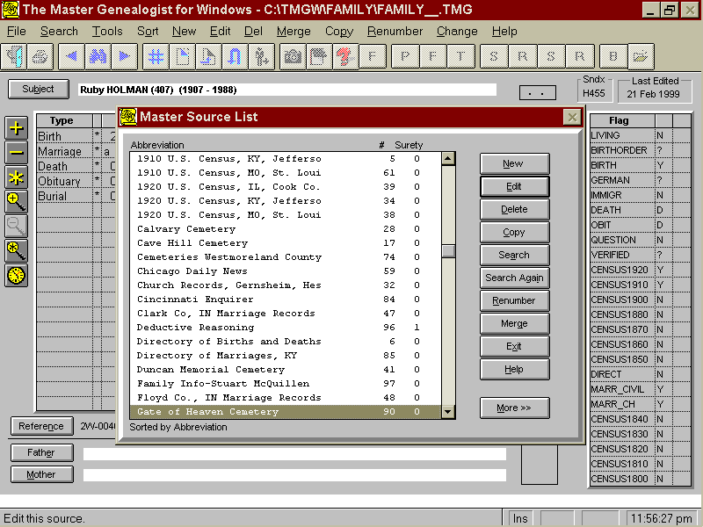

Conclusion

Citations should be used as quickly as you are willing to enter the documentation.

Information is only as good as your documentation verifying your sources.

