Using the Internet for Genealogical Research
KIPCUG Genealogy SIG March 15, 1999

Types of Sites
- Information Sites
- Index Sites
- Exchange Sites
- Chat Rooms
- Personal Web Pages

Information Sites
Sites listing information on how to research, maps, location of government records, how to obtain vital statistics records, etc.
http://yahoo.com & search “genealogy” & Arts>Humanities>History>Genealogy & Beginners’ Guides
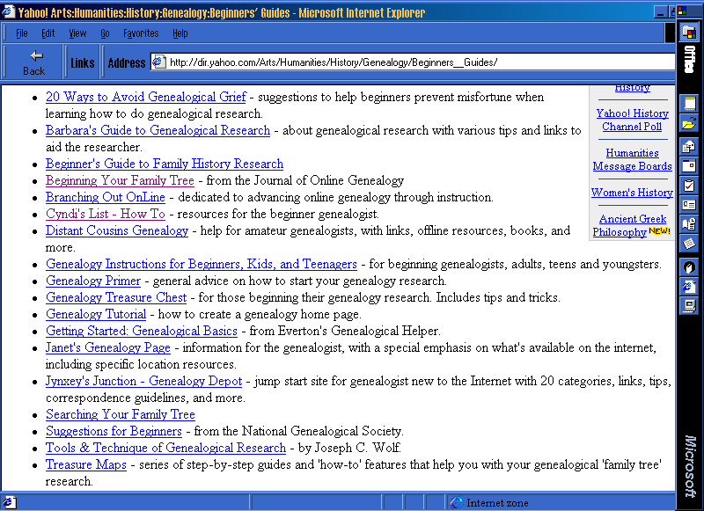

yahoo.com & Cyndi’s List & Getting Started & Genealogy 101
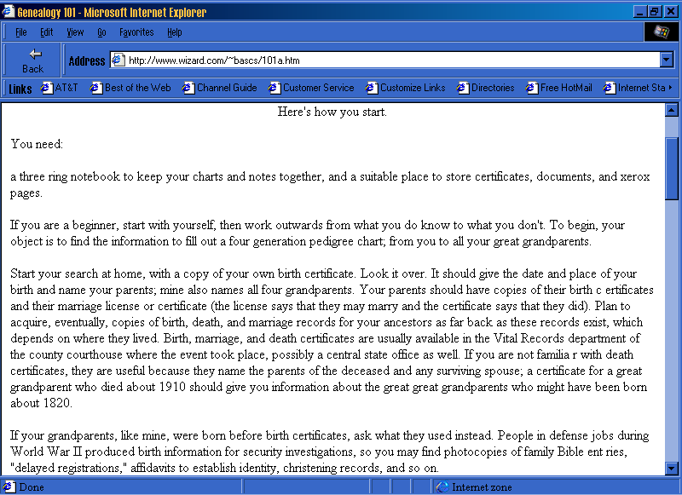

Index Sites
Sites listing an index of records, catalog of library holdings or census extracts, etc.
http://ukcc.uky.edu/~vitalrec/
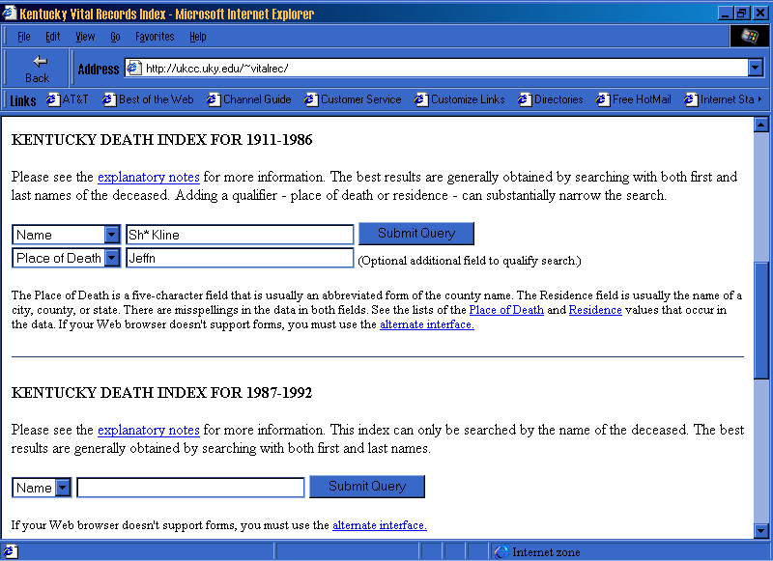

Search Results
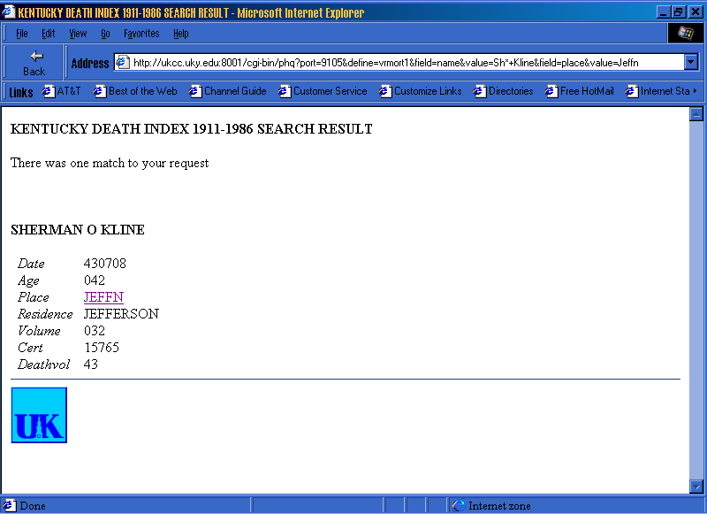

www.ancestry.com/ssdi/advanced.htm
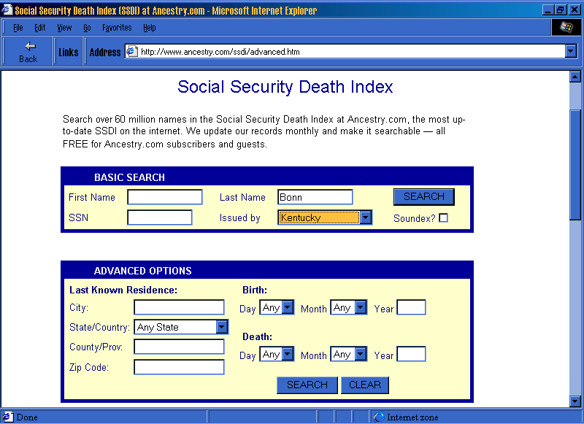

Search Results
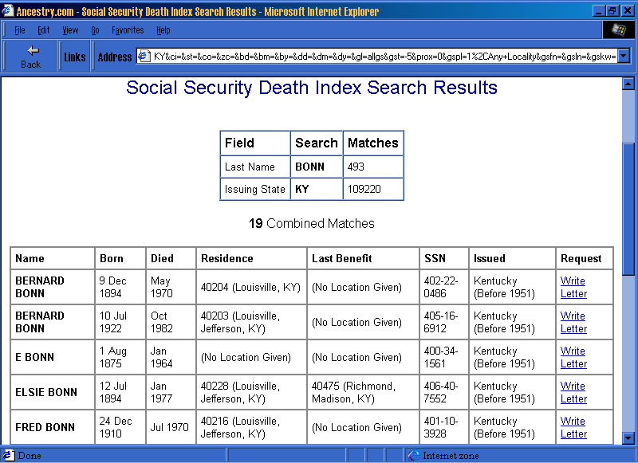

Exchange Sites
Sites accepting lists of names to be matched with names provided by other researchers with matches returned.

Chat Rooms
Sites that allow the free exchange of information quickly between all of the participants currently signed on to the site.

http://yahoo.com & search “genealogy” & Arts>Humanities>History>Genealogy & Chat
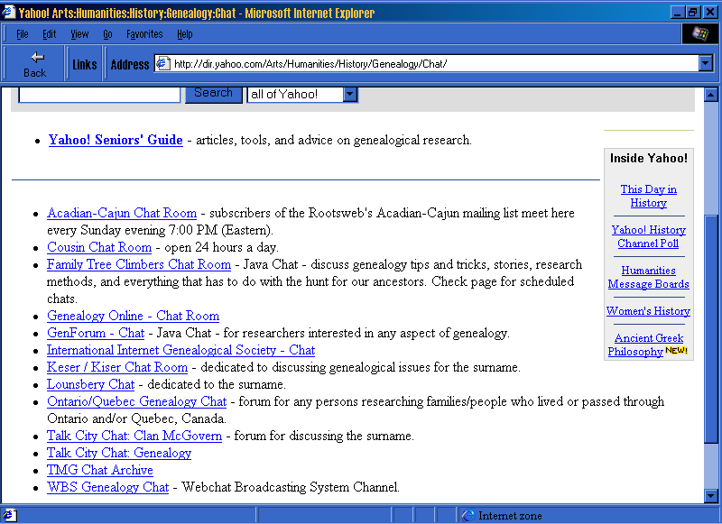

Personal Web Pages
- Can be used to make contact with other family members.
- Can be used as an easy way to allow your own information to be distributed without having to copy and send documents.

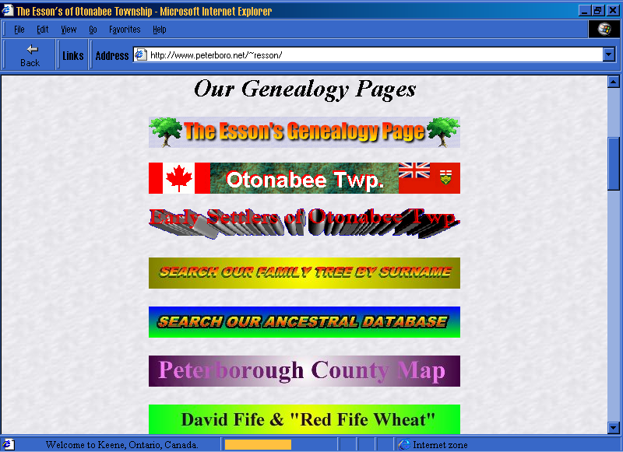
www.peterboro.net & Client Pages & Ron Esson

Caution!
Just because you see it on the internet does not make it right. Check your sources.

Sure Codes (TMG)
- 3 - Primary Documentation
- 2 - Secondary Documentation
- 1 - Guess
- 0 - No Information
- - - Disproved Information

Conclusion
The internet is the new way to conduct genealogical research. It is not the only way as it will be a long time, if ever, before all information is placed on the internet.

CAUTION: The URLs for the screen shots within this document were valid at the time the presentation was prepared (3/15/1999) and were therefore used as examples. The URLs have not been verified since. The URLs for some of the screen shots are included on the links page of this web site.

